**Criminal Record Management System**

Project Report

By

Shivam Shakya (2017244)

Vinit Kujur (2017291)

Abhishek Dhariwal (2017305)

CS-201 : Database Management System(DBMS)

Instructor : Dr. Pritee Khanna

Department of **Computer Science and Engineering**

PDPM Indian Institute of Information Technology, Design and Manufacturing, Jabalpur

**Acknowledgement**

It is indeed with a great pleasure and immense sense of gratitude that we acknowledge the help of these individuals.

We would like to thank our professor **Dr. Pritee Khanna**, Head of the Department of Computer Science and Engineering, PDPM Indian Institute of Information Technology, Design and Manufacturing, Jabalpur for this constructive criticism throughout our project.

Finally we express our heartful thanks to all of our friends who helped us in successful completion of this project.

**Shivam Shakya (2017244)**

**Abhishek Dhariwal (2017305)**

**Vinit Kujur (2017291)**

**ABSTRACT**

The purpose of the project entitled as “**Criminal Record Management System**” is to computerize the Management of Police Station to develop software which is user friendly simple, fast, and cost – effective. It deals with the cases, criminals, fir, victim, accused, etc. Traditionally, it was done manually. The main function of the system is store fir details, case details and Criminal details and retrieve these details as and when required, and also to manipulate these details meaningfully System input contains fir details, case details, while system output is to get these details on to the screen. The Criminal Record Management System can be entered using a username and password. It is accessible either by an administrator or a police officer. Only they can add data into the database. The data can be retrieved easily. The data are well protected for personal use and makes the data processing very fast.

**INDEX**

1. INTRODUCTION

1.1 Introduction

1.2 Problem introduction

1.3 Modules in the project

2. Design

2.1 ER - Diagram

2.2 Relational Model

3. SAMPLE SCREENSHOTS

4. CONCLUSION

5. BIBLOGRAPHY

CHAPTER 1

**INTRODUCTION**

**1.1 Introduction:**

The project Criminal Record Management system includes registration of fir, cases and criminals and storing their details into the database system.

The Criminal Record Management System can be entered using a username and password. It is accessible either by an administrator or an Officer. Only they can add data into the database. The data can be retrieved easily. The interface is very user-friendly. The data are well protected for personal use and makes the data processing very fast.

Criminal Record Management System is powerful, flexible, and easy to use and is designed and developed to deliver real conceivable benefits to police stations.

Criminal Record Management System is designed for advance police stations, to cover a wide range of police station administration and management processes. It is an integrated end-to-end crime Record Management System that provides relevant information across the Police station to support effective decision making for society care, police administration and critical financial accounting, in a seamless flow.

Criminal Record Management System enables you to develop your organization and improve its effectiveness and quality of work. Managing the key processes efficiently is critical to the success of the police stations helps you manage your processes

**1.2 Problem Introduction:**

**Lack of immediate retrievals: -**

The information is very difficult to retrieve and to find particular information like- E.g. - To find out about the criminals history, fir information, Victim details etc. the user has to go through various registers. This results in in convenience and wastage of time.

**Lack of immediate information storage: -**

The information generated by various transactions takes time and efforts to be stored at right place.

**Lack of prompt updating: -**

Various changes to information like cases details and details of criminals are difficult to make as paper work is involved.

**Preparation of accurate and prompt reports: -**

This becomes a difficult task as information is difficult to collect from various register.

**Objective:-**

1. Define FIR.
2. Recording information about the FIR to be registered .
3. Define Case.
4. Recording information related to crimes and status of cases .
5. Keeping record of the punishment provided to criminals.

These are the various jobs that need to be done in a Police Station by the investigating staff and inspectors. All these works are done on papers.

**Scope of the Project:-**

1. Information about FIR is done by just writing the Complainant's Name and Id, details of Occurrence of incident (eg. time, place, date). Whenever the Complainant comes up his information is stored freshly as a new User into the database then using the user ID we can add the information.
2. Status for a FIR can be updated time to time.
3. Case information is inserted from the fir ID, which contains Case information.

All this work is done manually by the officer and other investigating staff.

**1.3 MODULES:**

The entire project mainly consists of 2 modules, which are

* Admin module
* Police officer module

**1.3.1 Admin module:**

* manage station
* add crime
* add officer
* view officer details
* view station details

**1.3.2 Officer module**

* insert fir
* insert case
* view fir
* view case
* view Criminals

**CHAPTER 2**

**DESIGN**

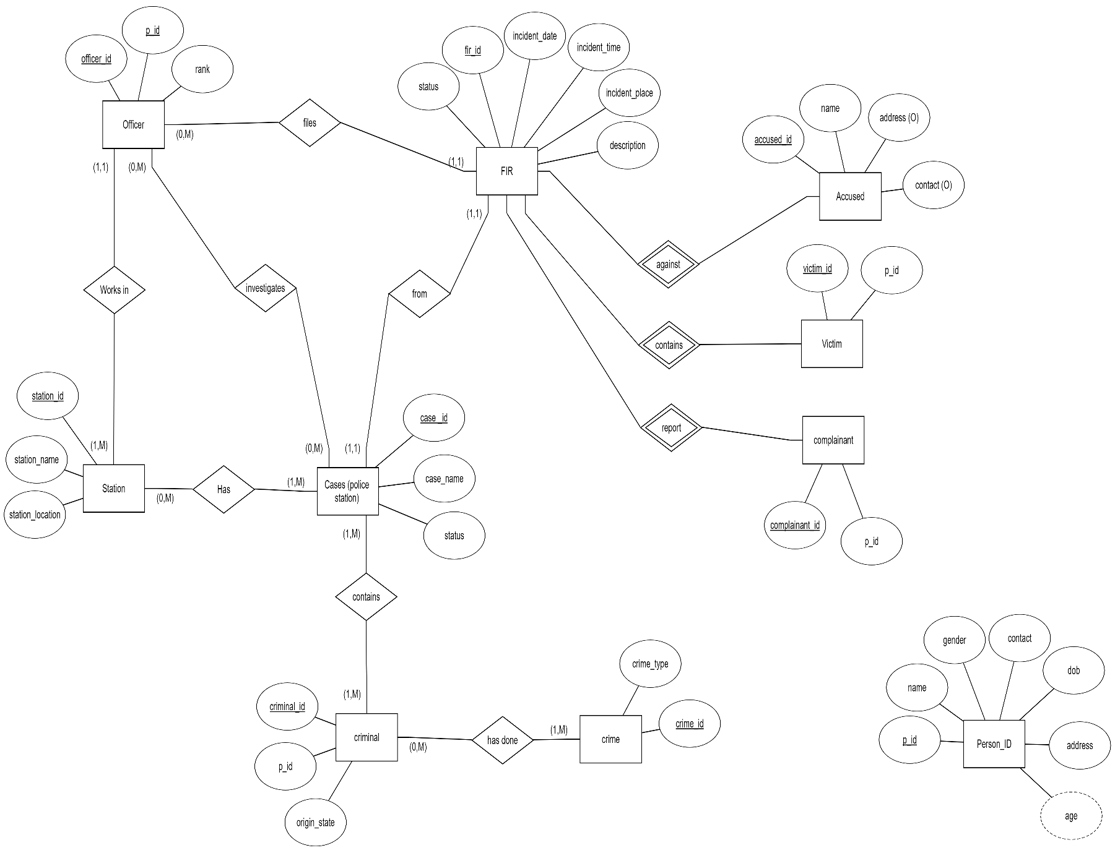**ER - Diagram**

**Relational Model**

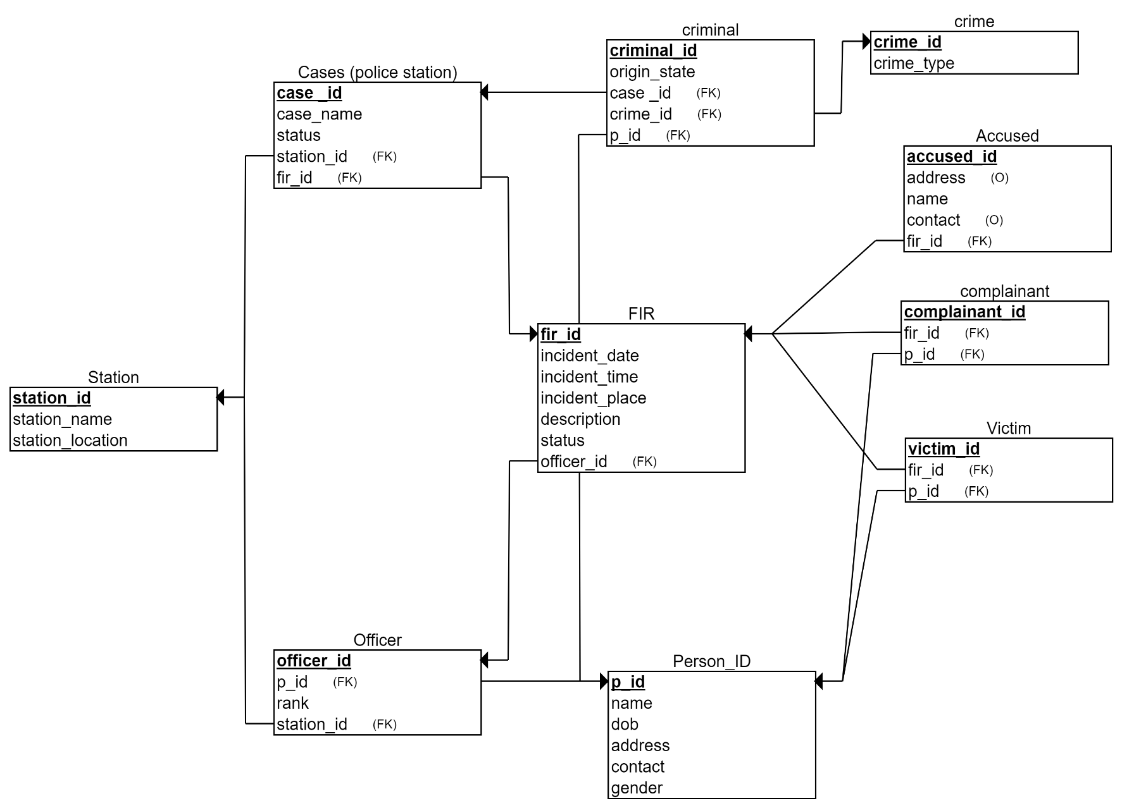

**CHAPTER 3**

**SAMPLE SCREENSHOTS**

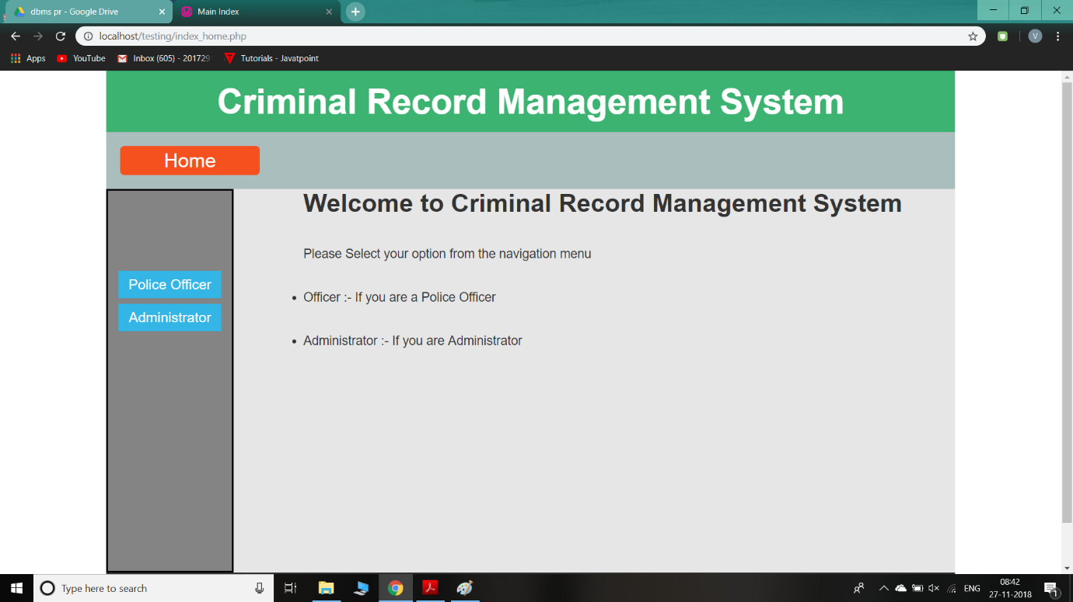**Home PAGE:**

**Admin Login:**

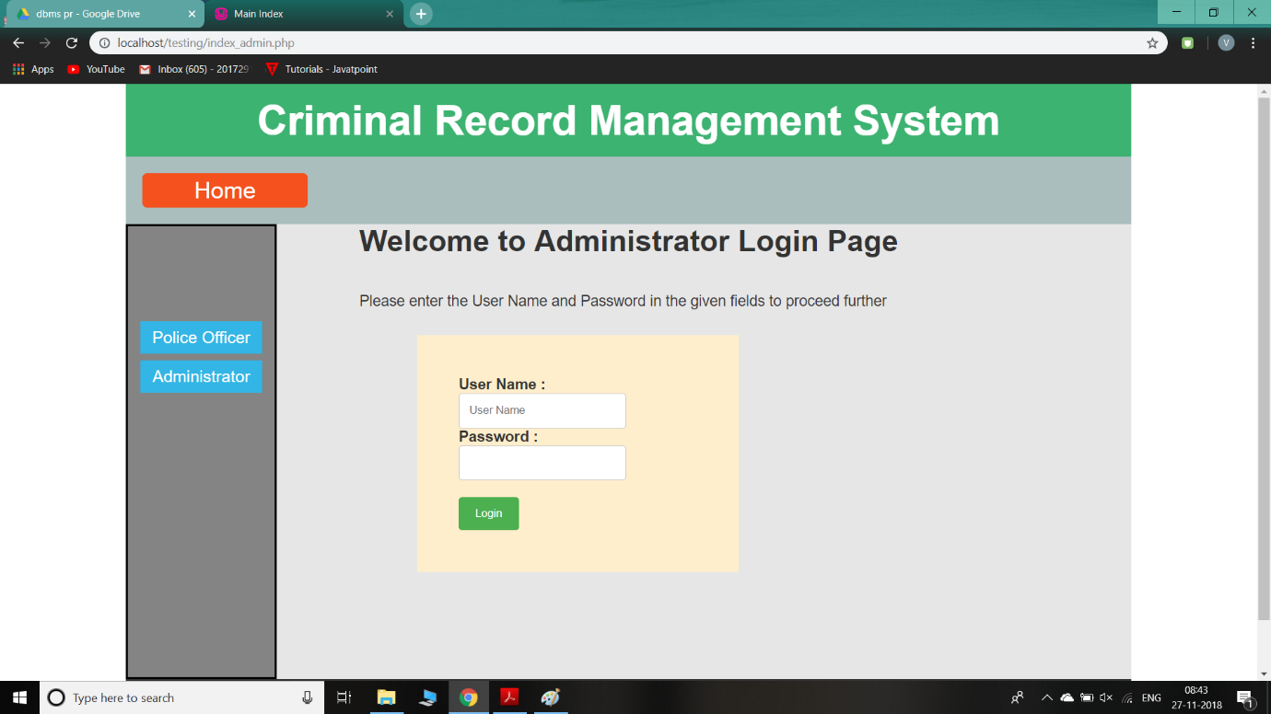

**Admin Options :-**

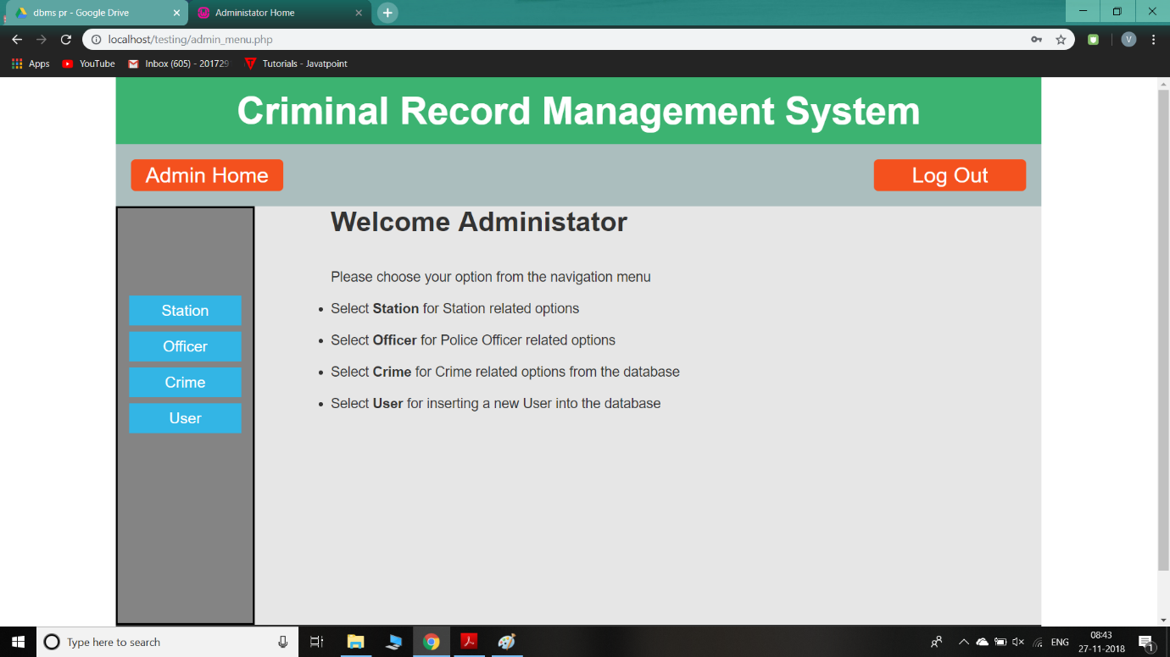

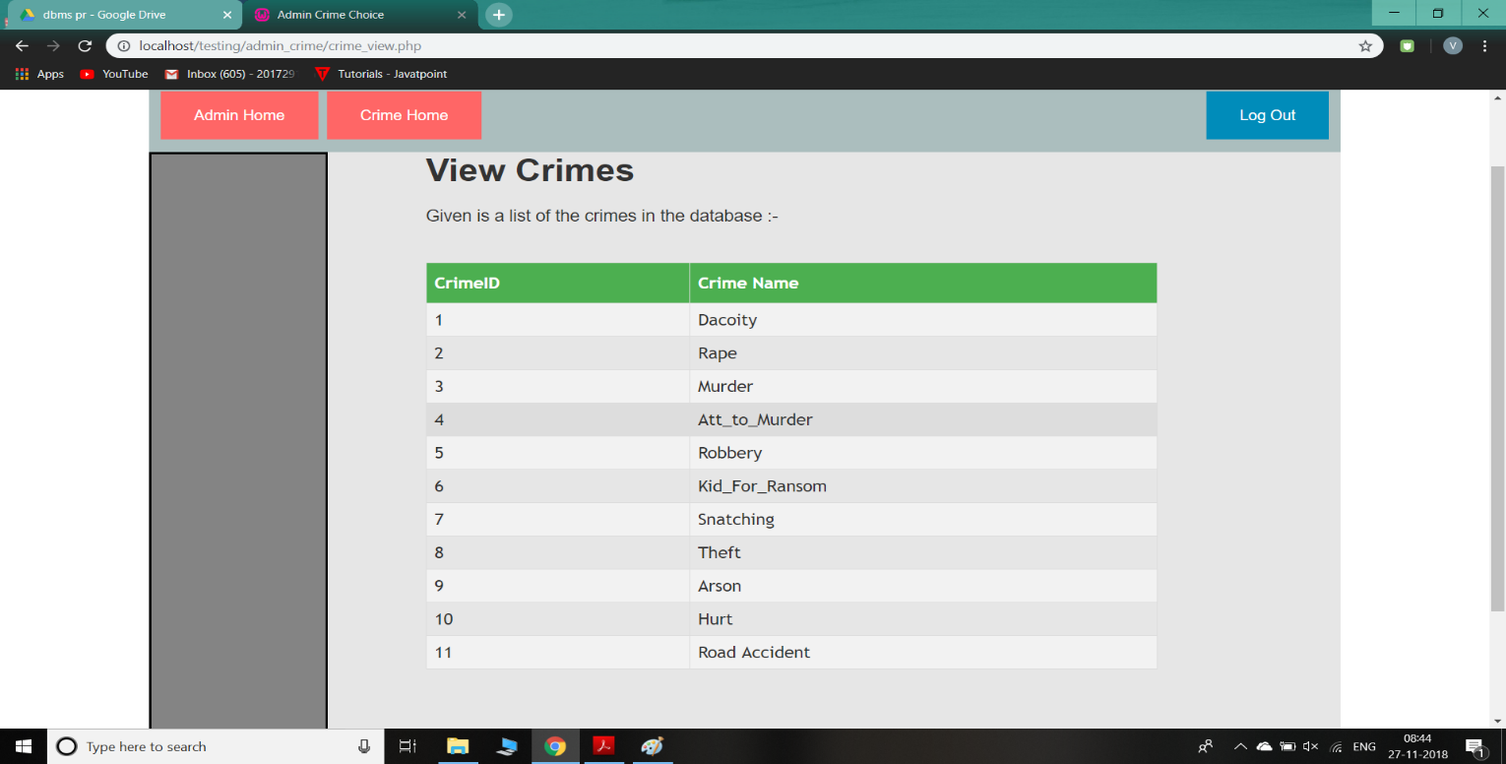**View Crimes:**

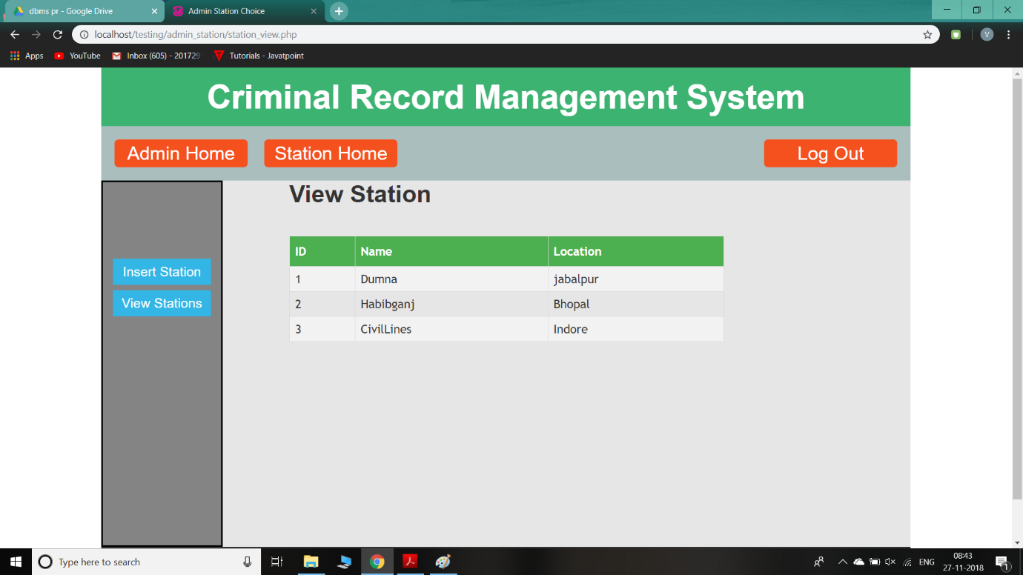**Station Details:**

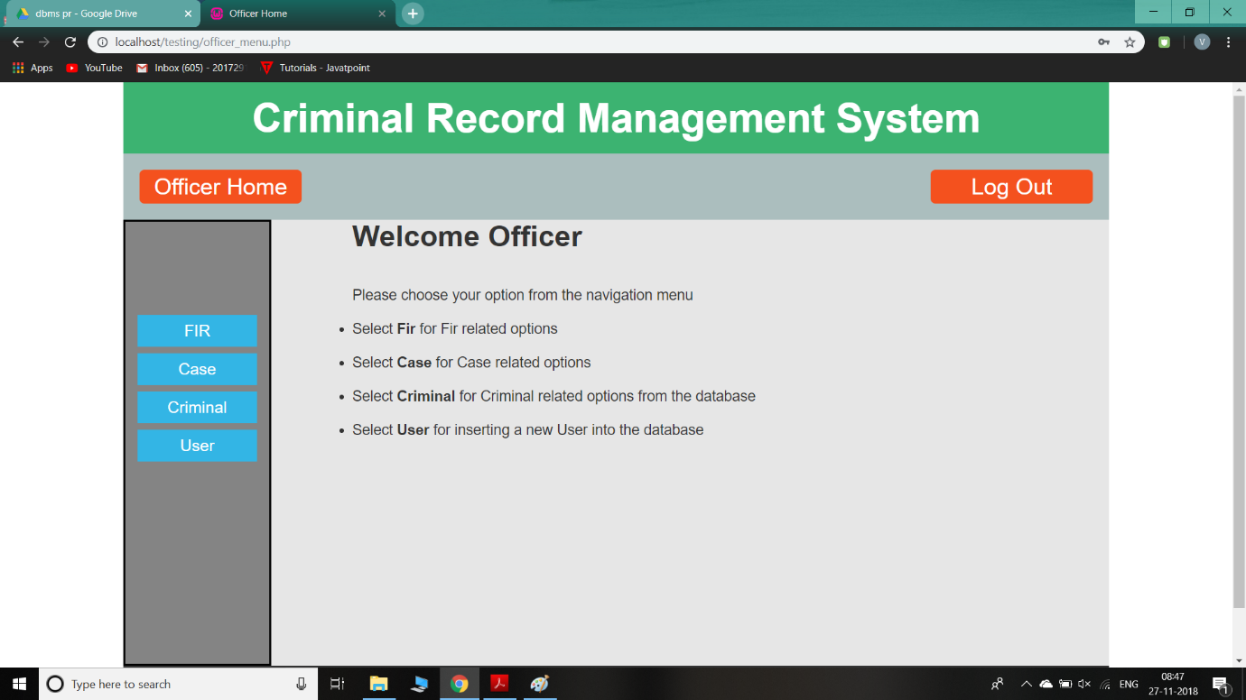**Officer Options :-**

**User Insert :-**

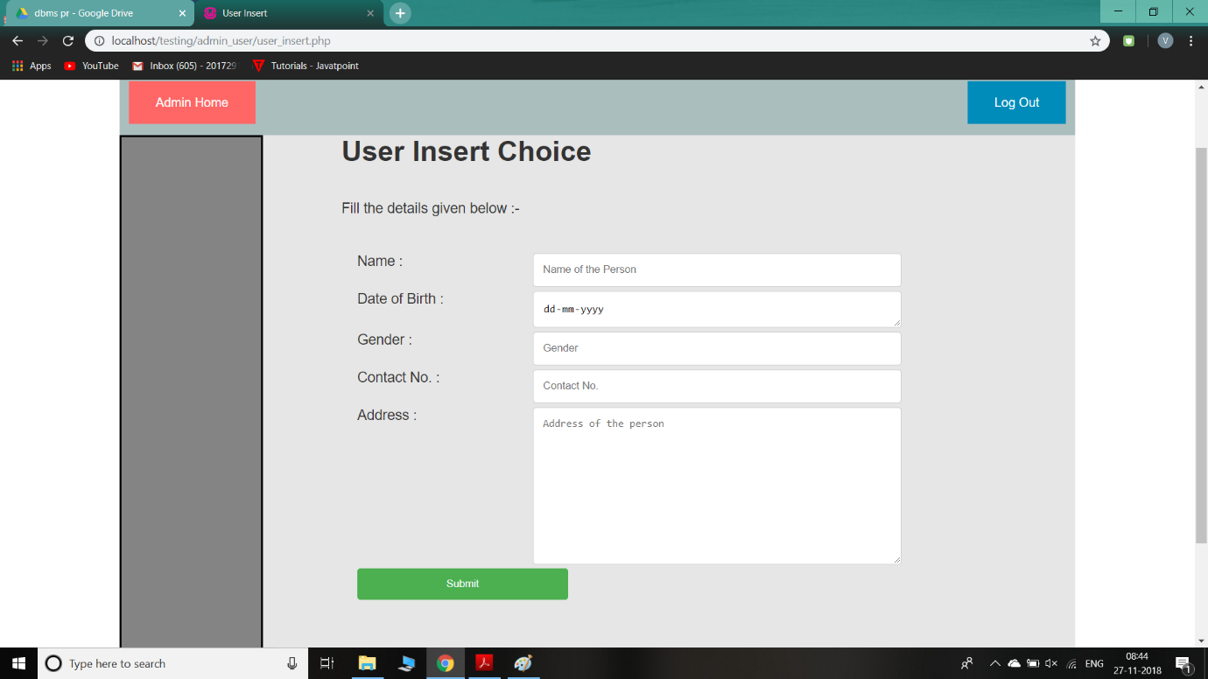

**View Fir :-**

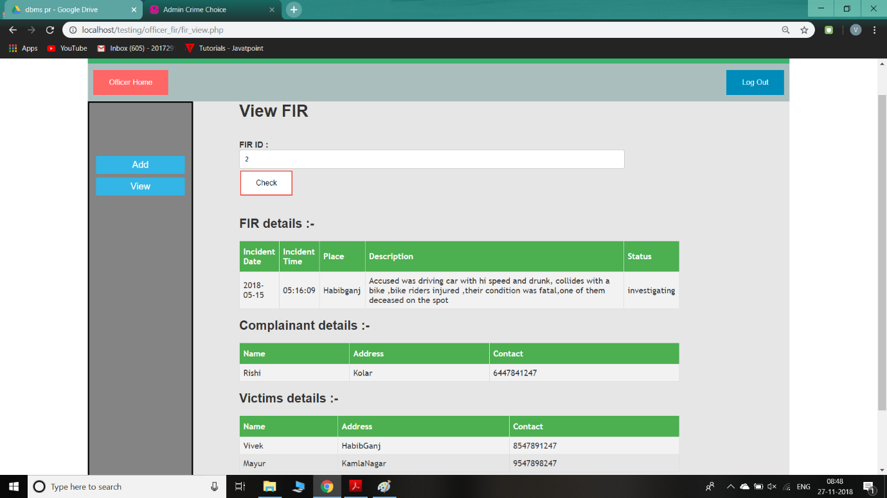

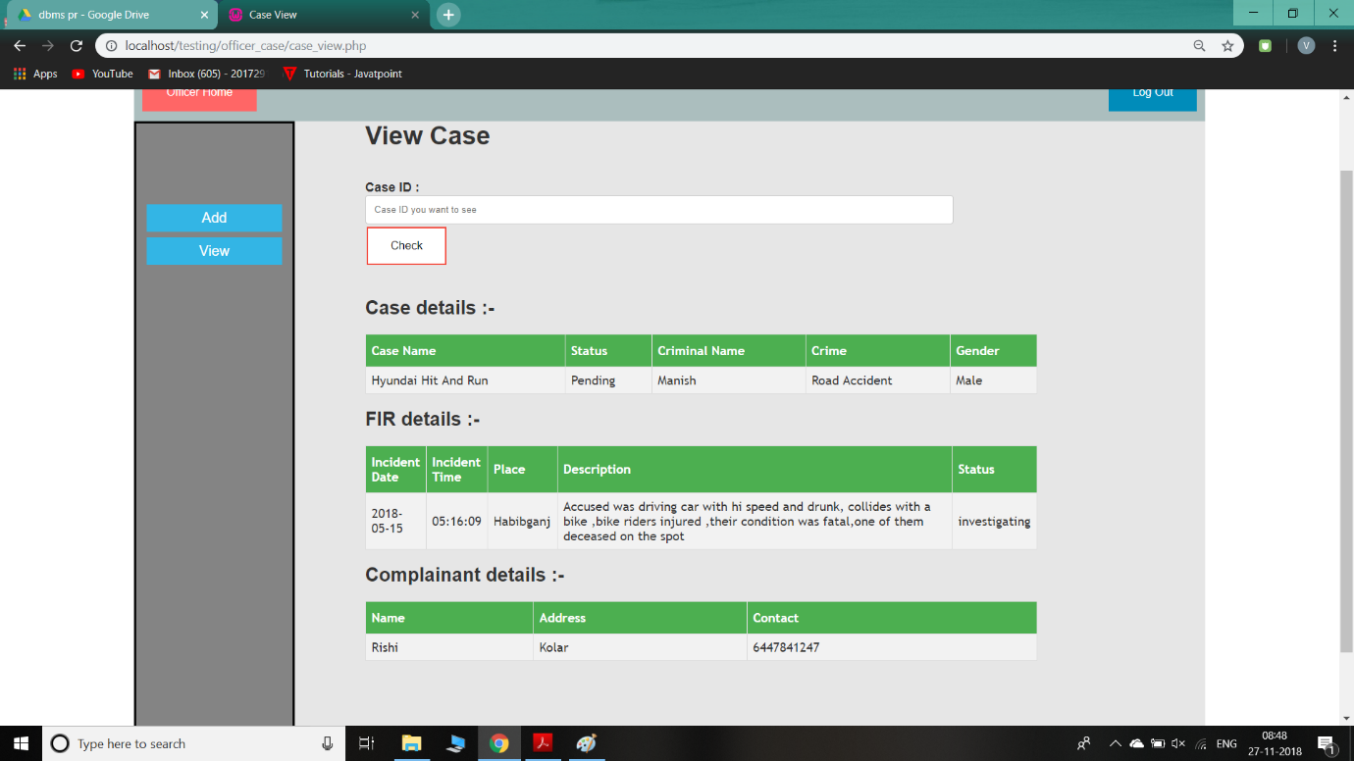**View Case :-**

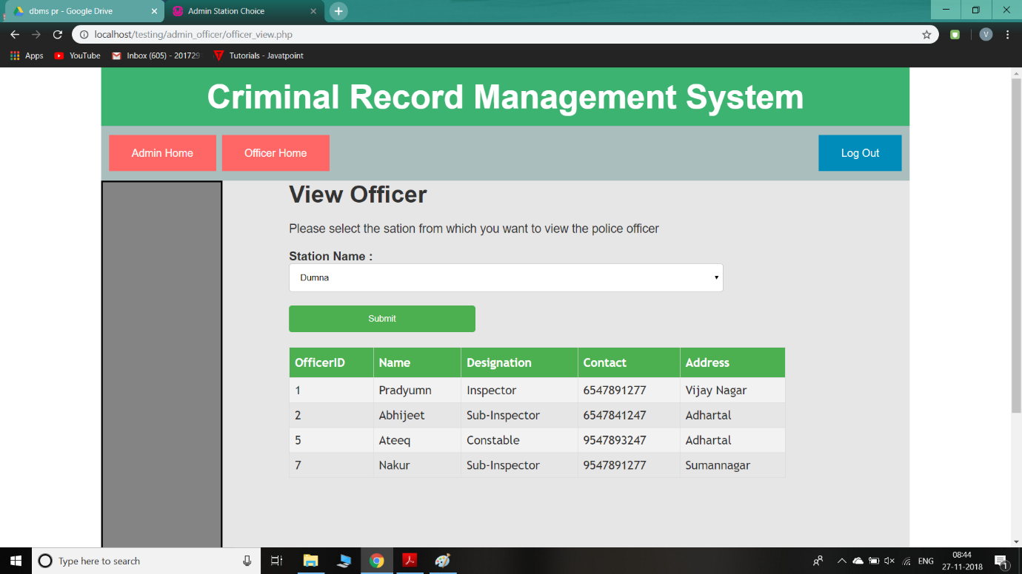**Officer from Station :-**

**4. CONCLUSION:**

Since we are entering details of the FIR and Case electronically in the “Criminal Record Management System”, data will be secured. Using this application we can retrieve fir details, case details, criminal history with a single click. Thus processing information will be faster. It guarantees accurate maintenance of FIR , Case and Criminal details. It easily reduces the book keeping task and thus reduces the human effort and increases accuracy speed. This results in **transparency** in the system and thus reduces the **corruption**.

**5. BIBLOGRAPHY**

* w3schools.com
* delhipolice.nic.in
* ncrb.gov.in
* Wikipedia.org